Impact of Tikhonov Regularization on Matrix Conditioning and Stability
Yuan-Yu Wang
Abstract
This study aims to discuss how the stability of a matrix impacts weight allocation in a portfolio consisting of highly correlated stocks. By calculating the condition number and analyzing the change of weights, we compared the performance of original unregularized matrix against regularized matrix when facing disturbances (changing a specific correlation coefficient). The results show that when the original is ill-conditioned, unregularized matrix exhibits drastic weight shocks due to small disturbances, while the condition number of a regularized matrix decreases significantly and the stability improves substantially, proving the great contribution regularization makes to improve the stability of a portfolio model.

- Introduction

In a portfolio, the higher similarity between componential stocks or the more in number of componential stocks, the higher correlation is among them. This derives problems of multicollinearity in predicting stock prices, leading to a failure in precisely estimating independent contribution of each factor. This may also make the matrix unstable since every tiny change causes drastic effects on coefficients. By fitting the random noise in training set, these abnormal coefficients cause overfitting, resulting in unsatisfactory performance in testing sets. In addition, when a matrix is ill-conditioned, some extreme positive and negative weights may emerge, which is unrealistic and implies excessive leverage risks in real-world investments. Therefore, to improve the problems stem from multicollinearity in financial market, this study uses Tikhonov Regularization to test and compare whether this method makes a matrix steadier in a high-similarity data set to proceed following predictions and calculating works.

  - What is Tikhonov Regularization?

We all know the formula of yield rate of a portfolio${ R}_{p}$

$$R_{p} = w_{1}R_{1}+w_{2}R_{2}+⋯+w_{n}R_{n} = \sum_{i=1}^{n}{w_{i}}R_{i}$$

$$R_{p }= w^{T}R$$

where $w_{i}$ are the weights of the i-th stock and $w$ is the weight vector. $R_{i}$ represents the return of the i-th stock, $R$ is the vector of stock returns.

For a portfolio, its risk is its variance. Hence portfolio variance can be calculated as

$$Var\left(R_{p}\right)=Var\left(w^{T}R\right)$$

$$=E\left[{\left(w^{T}R-E\left[w^{T}R\right]\right)}^{2}\right]$$

$$=E [ {(w^{T} (R - E [R] )) }^{2} ]$$

$$=E\left[w^{T}\left(R-E\left[R\right]\right){\left(R-E\left[R\right]\right)}^{T}w\right]$$

$$= w^{T}\{ E [ ( R - E [R] ){( R - E [R] )}^{T} ]\} w$$

and covariance matrix is

$Σ = E [ ( R - E [R] ){( R - E [R] )}^{T} ]$

Hence the variance of portfolio can be expressed by

$$Var\left(R_{p}\right)= w^{T}Σw$$

  - How to apply Tikhonov Regularization?

First, we minimize risk by finding minimal variance with function

$$\min_{w} f (w) ={\frac{1}{2}w^{T}}Σw$$

with condition that the sum of weights must be 1, conforming to $1^{T}w = 1$

Then, we input Tikhonov Regularization adjustment. Whenever correlations among stocks are too high, the original covariance matrix approaches singular and unsteady. This also occurs in multicollinearity problems when using Ordinary Least Squares method: sacrificing stability to ensure the unbiasedness of the model. Therefore, we adjust objective function by applying regularization parameter $λ$ to covariance matrix $Σ$, to control the trade-off between unbiasedness and stability.

$$\min_{w}{\frac{1}{2}}w^{T}( Σ + λI )w$$

As we just mentioned above, $Σ$ is covariance matrix reflecting the deviation among stocks’ yield rates. After being standardized, it reflects the relative linearity among stocks’ yield rate, which is the correlation matrix $C$. Hence the relationship between $Σ$ and $C$ can be expressed as

$$Σ =DCD$$

with $D$ being the diagonal matrix consisting of standard deviations of each stock, each being equal to 1. That is, $D$ = $I$

Given that $C$is a correlation matrix, its entries on the diagonal are all 1s since they are their correlation coefficients to themselves. Other entries are correlation coefficients between two distinct stocks, thus we know $C$ is a symmetric matrix and the range of each entry is [-1, 1]. Therefore, it can be diagonalized as $C = QΛQ^{T}$. In this equation, $Λ$ is a diagonal matrix with each entry being the eigenvalues of matrix $C$. In addition, $C$ has the properties of positive semi-definite, meaning all eigenvalues are more than or equal to 0.

Then we add the regularization term $α$ to correlation matrix $C$ and let $C^{'}$ ＝ $C + αI$. Thus we get the diagonalization result $C^{'} = Q (Λ + αI) Q^{T}$, meaning the eigenvectors of $C$ and $C^{'}$ remain unchanged while each eigenvalue increases by $α$. Therefore, the minimal eigenvalue will be a positive $α$, making $C^{'}$ positive definite and invertible.

By assuming $D$ = $I$, we focus on the analysis of high correlation among the assets, which is the primary source of instability in highly similar portfolios. As a rsult, the covariance matrix equals to the correlation matrix, making the regularization parameters $α$ and $λ$ identical. To simplify, in the following paragraphs, we use a unified $α$ in our verification.

- Methodology
  - Basic information
To simplify the verifying process, we assume the standard deviations of all stocks are 1, implying the identical risk volatility. Hence, we replace covariance matrix with correlation matrix.
This study selects 30 technological constituent stocks in S&P 500 as research subjects and collects their closing prices within one month. If any data is missing, we use that of the day before to compensate and finally delete empty information to ensure the completeness of time-series. After that, we calculate daily yield of every stock. To eliminate the disturbances to matrix’s steadiness by volatility of individual stock, this study assumes the standard deviations of all stocks are 1s and focus on the numerical properties of a correlation matrix.

  - Index of steadiness: condition number

To quantify the sensitivity of a matrix toward error, we set condition number as a measuring index defined as the ratio of maximal eigenvalues and minimal eigenvalues.
$$Condition Number= \frac{\left|λ_{max}\right|}{\left|λ_{min}\right|}$$

A small condition number of a matrix represents a steady distribution among stocks and a stable calculated result. On the contrary, a large one indicates a high correlation among stocks. Hence a matrix with a large condition number leads to unsteadiness and extreme sensitivity toward tiny fluctuations.

  - Experimental Comparison

In this study, we design two groups of experiments to verify the effect of regularization, which are sensitivity tests on the original matrix and the regularized matrix. This study set the regularization coefficient, $α$, as 0.01, while the value of tiny disturbance is 0.005 and observe their volatilities toward weights.

- Empirical Study

Pictures below show the variations on weights of stocks’ prices with and without Tikhonov Regularization.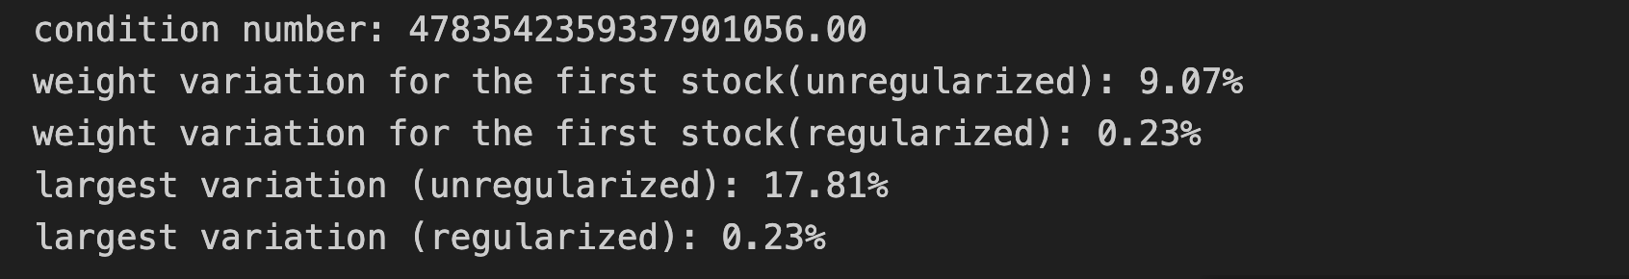 The result shows the original conditional number is as high as ${4.78*10}^{18}$, confirming matrix consisting of high-correlation technological stocks is extremely ill-conditioned. Merely little adjustment as 0.005 in correlation coefficient stimulates unsteadiness and makes the result shift by 17.81%. However, after being regularized, the steadiness of the matrix increases significantly and compresses the weight variation within 0.23%, which is a significant decrease comparing to the unregularized matrix. The comparing results indicates regularization can curb the error amplification effect derived from multicollinearity, contributing to better steadiness of a portfolio toward market noises.

  - Comparison of Heatmaps for the Unregularized and Regularized Model
After comparing heatmaps of the original matrix and regularized matrix, we found that their structures are almost identical. In other words, regularization does not distort the original data structure. Nevertheless, the condition number dramatically drops from approximately 4.78*${10}^{18}$ to approximately 928, improving significantly on the stability of a matrix.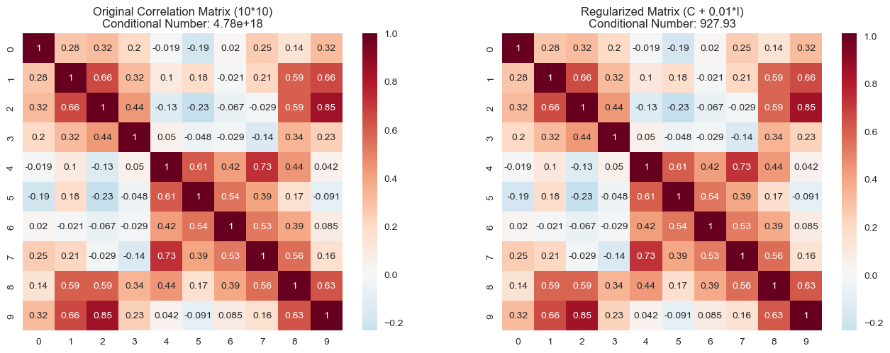
  - Comparison of Histogram for the Unregularized and Regularized Model
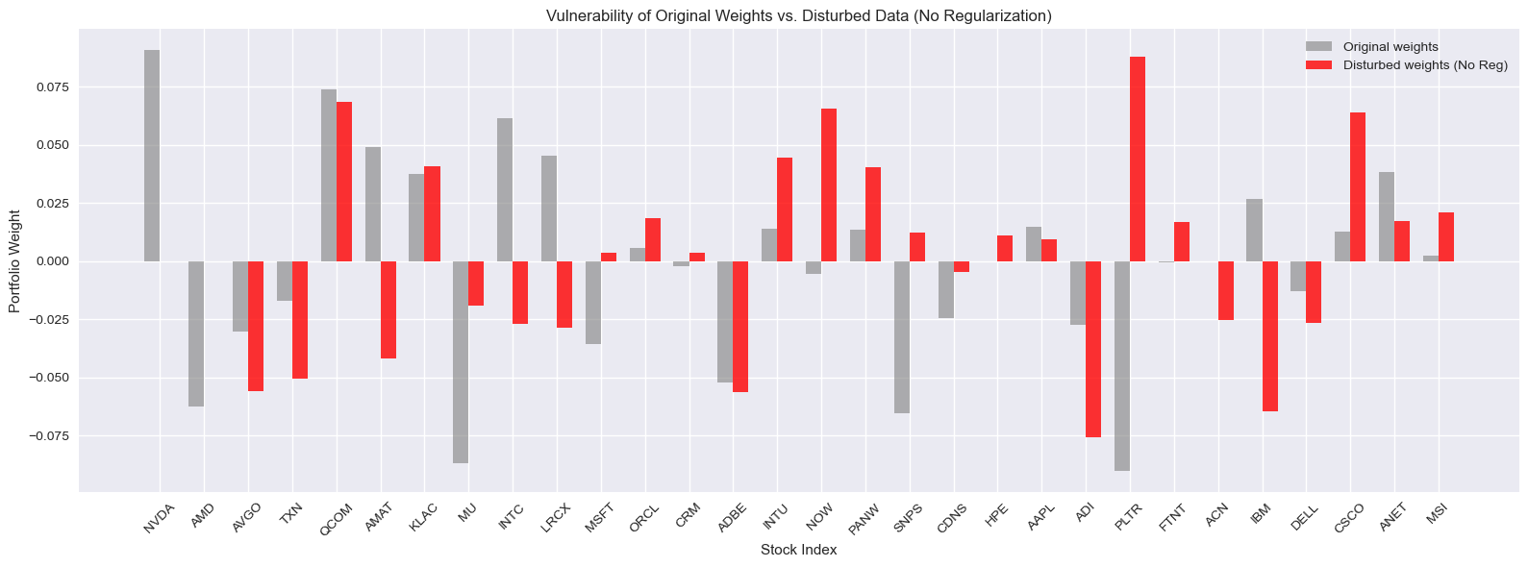
The histogram above shows the original matrix with and without tiny disturbance and neither of them are regularized. We can see that although the variation of correlation coefficient, which we mentioned as disturbance, is extremely small (0.005), the deviation from original matrix is immense. What’s more, some even have opposite trading directions. In a word, this matrix is very unstable.

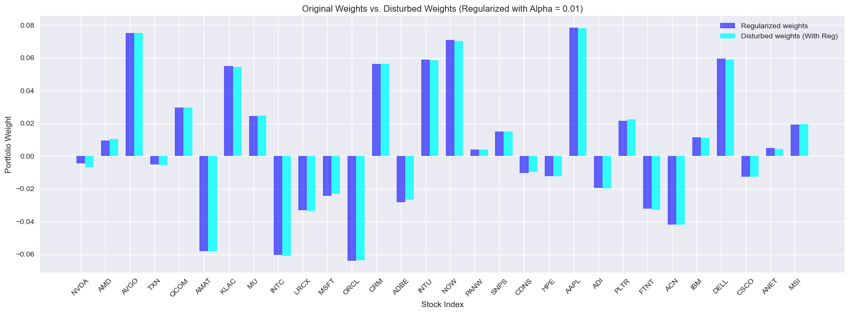 This histogram illustrates original matrix without and with disturbance after being regularized. According to the graph, the weights of both matrices are highly overlapping. This demonstrates Tikhonov Regularization enhances the steadiness of a portfolio effectively and ensures the practicality of a matrix.

- Conclusion

This project successfully converts model consisting of 30 technological constituent stocks in S&P 500 into a more stable model through Tikhonov Regularization, which decreases the portfolio’s sensitivity to a disturbance. By stabilize the eigenvalues of a model, we solve the problem of difficulty in matrix inversion when a matrix is nearly singular and improve the stability of computation. In addition, it also solves the problem of extreme asset weights due to high correlation, exhibiting better robustness to noise.

Specific to the content of this project, I am interested in further studies related to the coefficient of regularization, $α.$To simplify the complexity of verification of regularization, this project chooses to set a fixed value on coefficient of regularization. However, distinct coefficient of regularization may impact on the profitability and steadiness of a portfolio. Therefore, the methods of improving the coefficient of regularization such as Generalized Cross-Validation in machine learning and L-curve can be the directions of my further study.

- Reference

https://www.ibm.com/think/topics/ridge-regression#1190488336

https://haosquare.com/l1-l2-regularization/

https://allen108108.github.io/blog/2019/10/22/L1%20,%20L2%20Regularization%20%E5%88%B0%E5%BA%95%E6%AD%A3%E5%89%87%E5%8C%96%E4%BA%86%E4%BB%80%E9%BA%BC%20_/

https://blog.csdn.net/ZSZ_shsf/article/details/54022509

https://www.sciencedirect.com/science/article/pii/S2307410825000926

https://tomohiroliu22.medium.com/%E6%A9%9F%E5%99%A8%E5%AD%B8%E7%BF%92-%E5%AD%B8%E7%BF%92%E7%AD%86%E8%A8%98%E7%B3%BB%E5%88%97-11-%E6%AD%A3%E5%89%87%E5%8C%96-regularization-lasso-regression-%E5%92%8Cridge-regression-52bc9d3794e6

https://blog.csdn.net/sinat_26917383/article/details/52092040

